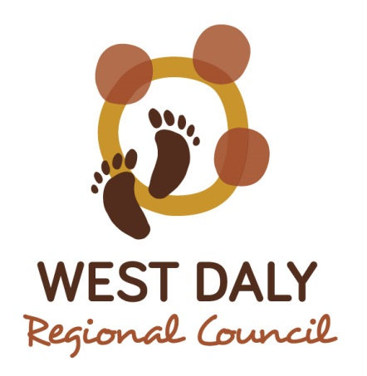

MEETING OF WADEYE
LOCAL AUTHORITY

10:00am Thursday 11th December 2014
Held at the Council Office

This meeting is open to the public excluding confidential Local Authority business.

Agenda available by COB Monday 8th December 2014,
Please contact Council Service Office.

AGENDA

Wadeye Local Authority Meeting
10:00am, Thursday 14th August, 2014 Wadeye Council Office

- Present
- Apologies/ Absent
- Disclosure of interest – Members and Staff
- Confirmation of previous Minutes
- Action items from previous Local Authority Minutes
- Call for items of general business
  - Local Authority Members
  - Local Authority Training
  - Cemetery Act Review
  - Local Authority Community Plan meetings
- Chairperson update
- Visitor presentations
- General Business
- Next meeting
- Meeting close

